Response to change

Template

Please complete this section of the template before doing the research.

Step 1:

Think of two change experiences you have recently experienced and on the template provided, provide an overview of what the change was.

1. A change imposed upon you – where you felt like you didn’t have a choice in the change. It can a be a small or large change; gradual or sudden; expected or unexpected.
2. An intentional change where it was a conscious decision by you to initiate or support a change.

|  |
| --- |
| Change that was imposed on me:  It’s the time when I have to decide which engineering field I have to join. At that time I was curious about automobiles and I wanted to be a designer in that field but my dad says that I should join computer science and they put me in CS field. |
| Change that was intentionally generated by me:  I was my 4 semester going on and I was doing good in the field of Hacking but then for a change I started studying machine learning and I saw that I was doing exceptionally good in that field so I change my career path to be a Data Scientist rather than an Ethical hacker. |

Step 2:

Think about and record the range of reactions you experienced (mindset/emotions and behavior) as you went through the changes – from the beginning to the end.

|  |
| --- |
| The range of reactions experienced for the change that was imposed on me was:  Earlier I was very angry on my dad’s decision but with  the time my interest in that field was increasing exponentially  And later on I felt that my dad’s decision was right. |
| The range of reactions experienced for the changed that I intentionally generated was:  I was very curious about it and at some stage I find it to be difficult but inside I was know that I have to do work hard to accomplish my goals. |

Step 3:

Complete the reading and research in the additional resources to get a better understanding of ‘why’ you experienced what you did and then complete the next page.

Step 4:

Now that you’ve done your research about the Change Curve, please complete the final section. Here is a reminder of the Change Curve:

The Kübler-Ross change curve

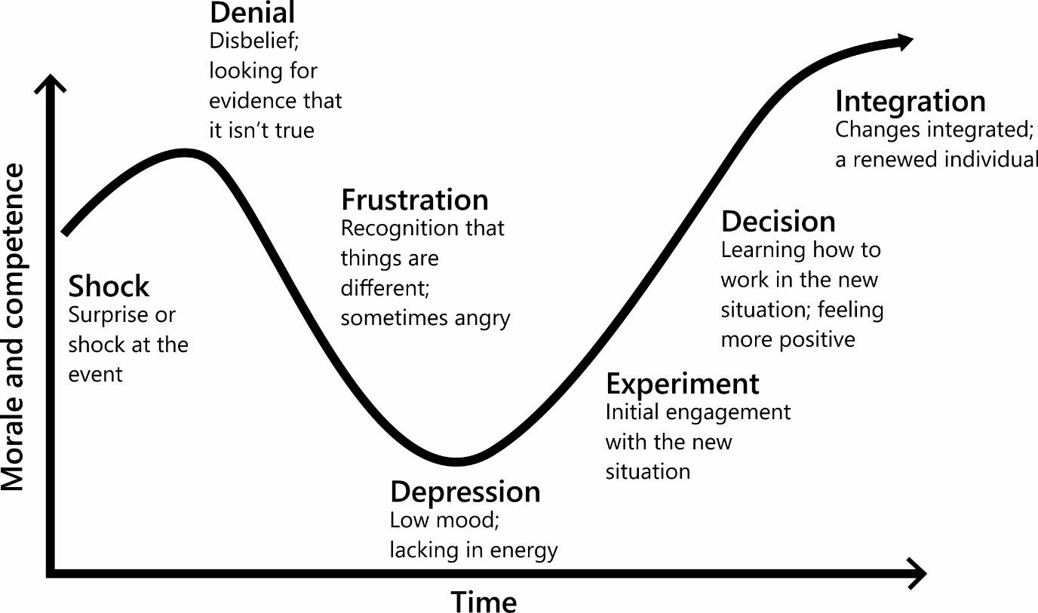

Step 5:

Identify what you have learnt from reflecting on this experience. Thinking back to the changes you wrote about earlier, identify what you have learnt from reflecting on this experience. It would also be beneficial to detail what happened at each stage of the Change Curve for you.

|  |
| --- |
| My reflections and learnings for the change that was imposed on me:  Shock: I was shocked when my dad said “You have to join CS instead of Automobile Engineering”.  Denial: I definitely had a moment of denial as I was so upset because they are forcing me to do something in which I don’t have any interest.  Frustration: I was so frustrated when I go to the classroom for the first time.  Depression: I had a moment when I was totally depressed as I was studying something opposite to my interest and as a result I got failed in 2 subjects.  Experiment: In my second semester I see many of my friends are from different states and they all have different field of interests there are some who don’t like CS but even after this they are getting good grades. I joined their group and with the time I realize that anyone can build interest in something if he/she is willing to. After realizing this I start building interest in that field.  Decision: After experimenting I found that my result grades are getting good. I was very happy and I took a decision that now I have to excel in this field.  Integration: The change is now integrated and working well and I found myself more interested in this field(CS). |
| My reflections and learnings for that change that I intentionally generated:  Shock: I was not shocked as it was my decision to start studying Machine learning.  Denial: When I found that it needs good math skills I was about to left  this.  Frustration: I was so frustrated when I started learning essential math for Machine learning.  Depression: I had a moment when I was totally depressed because I am studying the thing which I hate the most i.e. Math.  Experiment: To evaluate my skills and take rest from doing math all the time I start doing a project and that was my first project in Machine  learning and I completed it in 10 days and I submit this project code and report to my trainer and he was so impressed from my project and after completing my training I got two certificates one for training completion and second one was appreciation of my project work.  Decision: After experimenting I found that my skills are enhancing. I was very happy and I took a decision that now I have to excel in  this field.  Integration: The change is now integrated and working well and I found myself more interested in this field than Hacking. |

Any final thoughts or reflections on how you could deal with change more effectively in the future?

I believe that if I found something which can help me to reach to my career goal, I will do it no matters whether I have an interest in it or not.